

**S R College of Professional Studies**

**A**

**Report**

**On**

**Expert Lecture on Future Prospects inthe Field of Computer Science & Engineering**

**29/11/2021**

S R College of Professional Studies organized an “Expert Lecture on Future Prospects In The Field of Computer Science & Engineering” for the students of Bachelor of Computer Application 1st year,2nd year &3rd year. The expert talk was delivered by Lt Akhil ShuklaIRTS (Senior DCM NCR Jhansi).

The lecture was started by describing the importance of computer technology in the future and how students get the better opportunities in Mnc’s and in government sector. He explained that students who have pursued computer application degree will have an edge over engineers from other streams because of the knowledge and skills they gather in college. There is a huge Future Scope of computer application in terms of placements. In fact, it has taken the top position in placements as compared to the other fields.

**CSE offers some of the highest paying jobs not only in India but also outside. There are people who do freelancing and get paid very well.**

Overall, the lecture was very interesting and beneficial to all the students.

The list of students& photographs of the expert lecture are enclosed herewith:

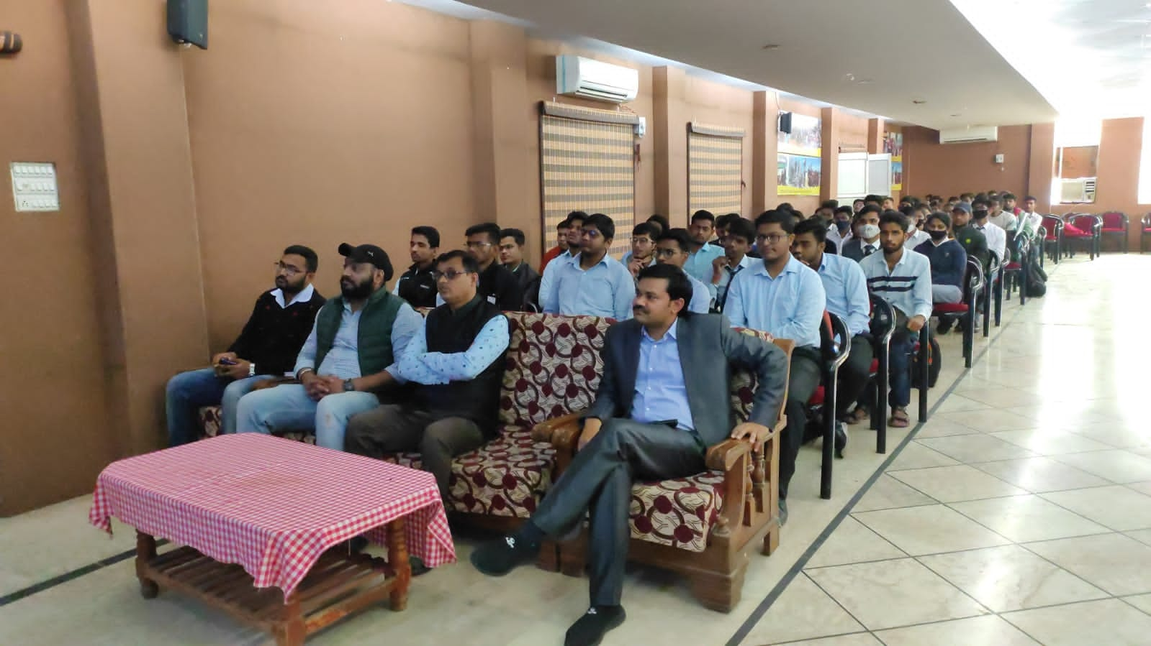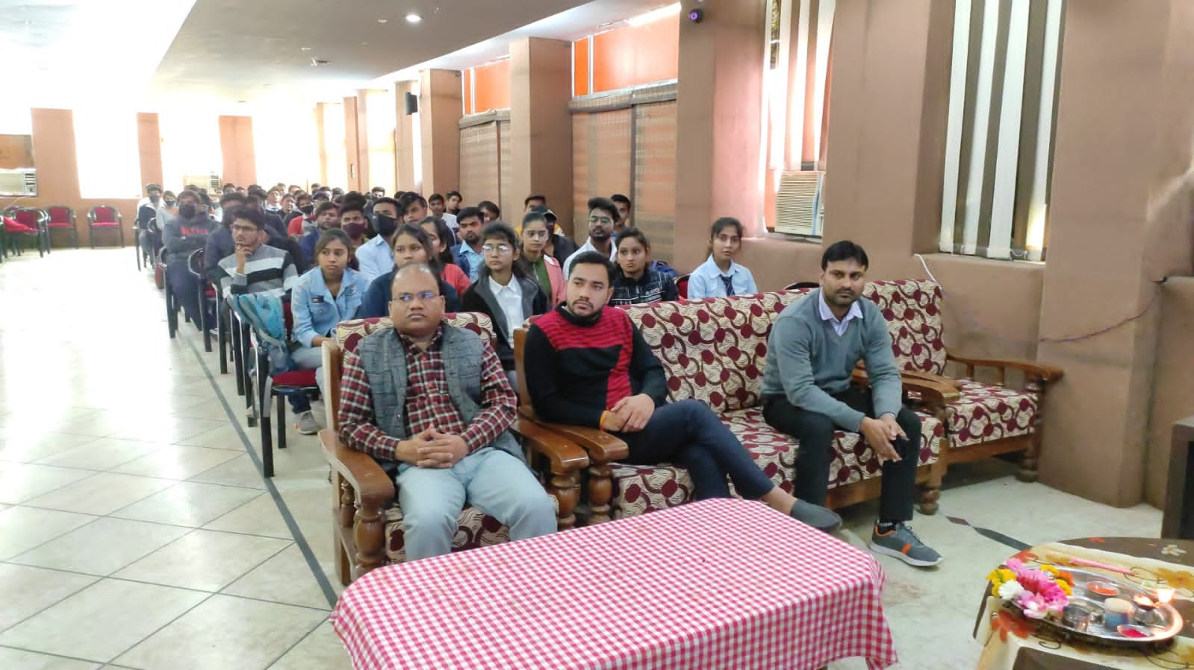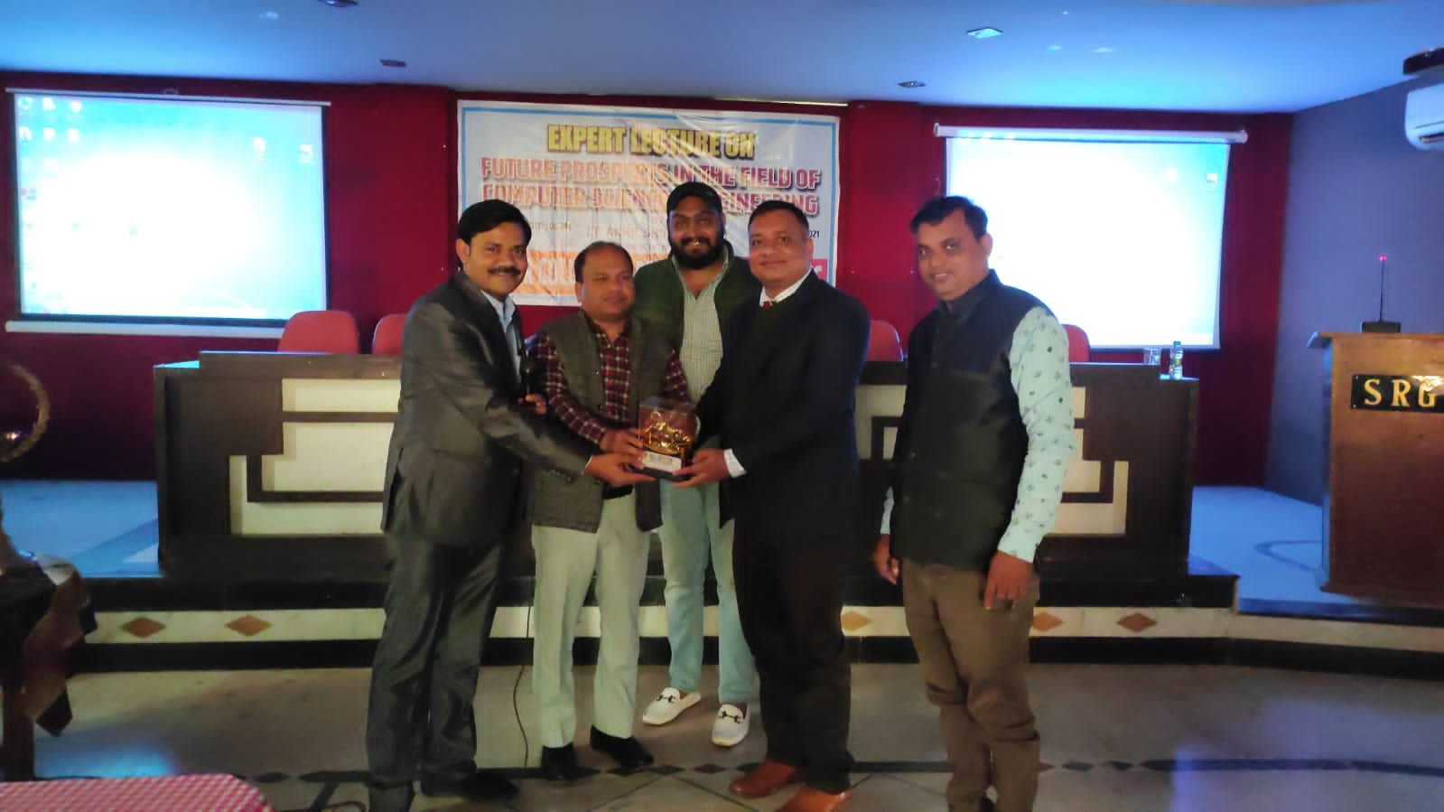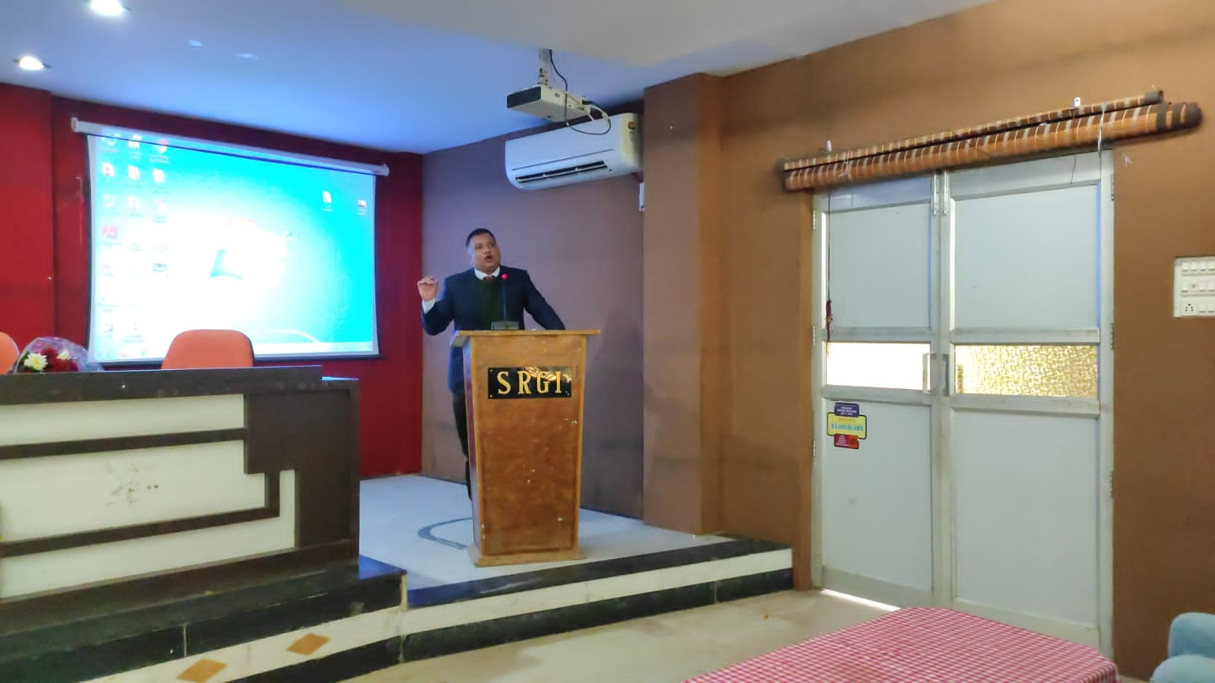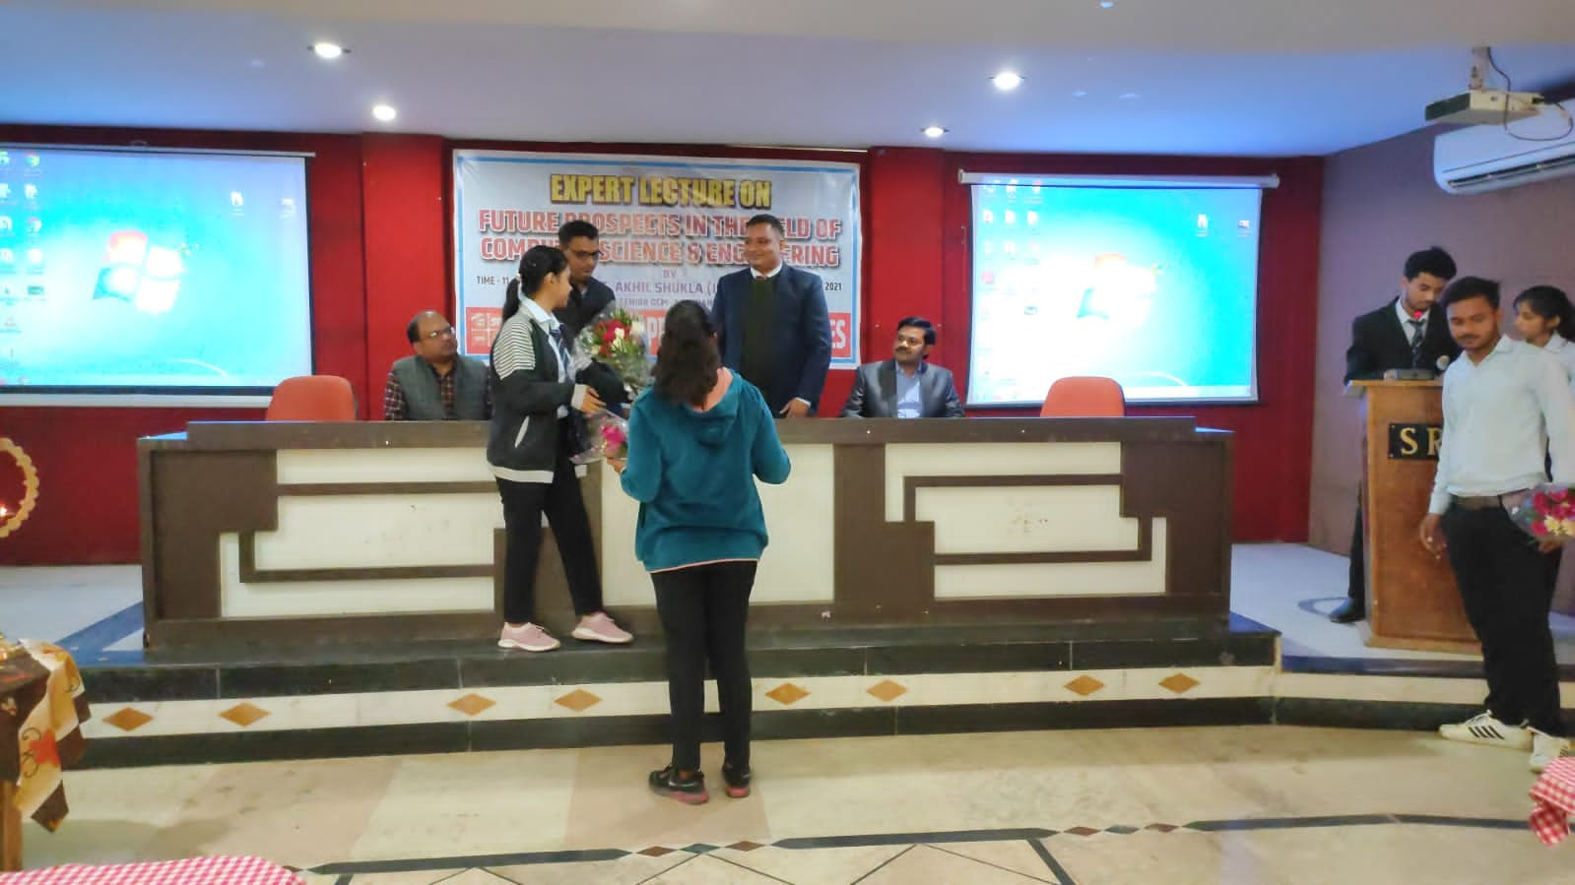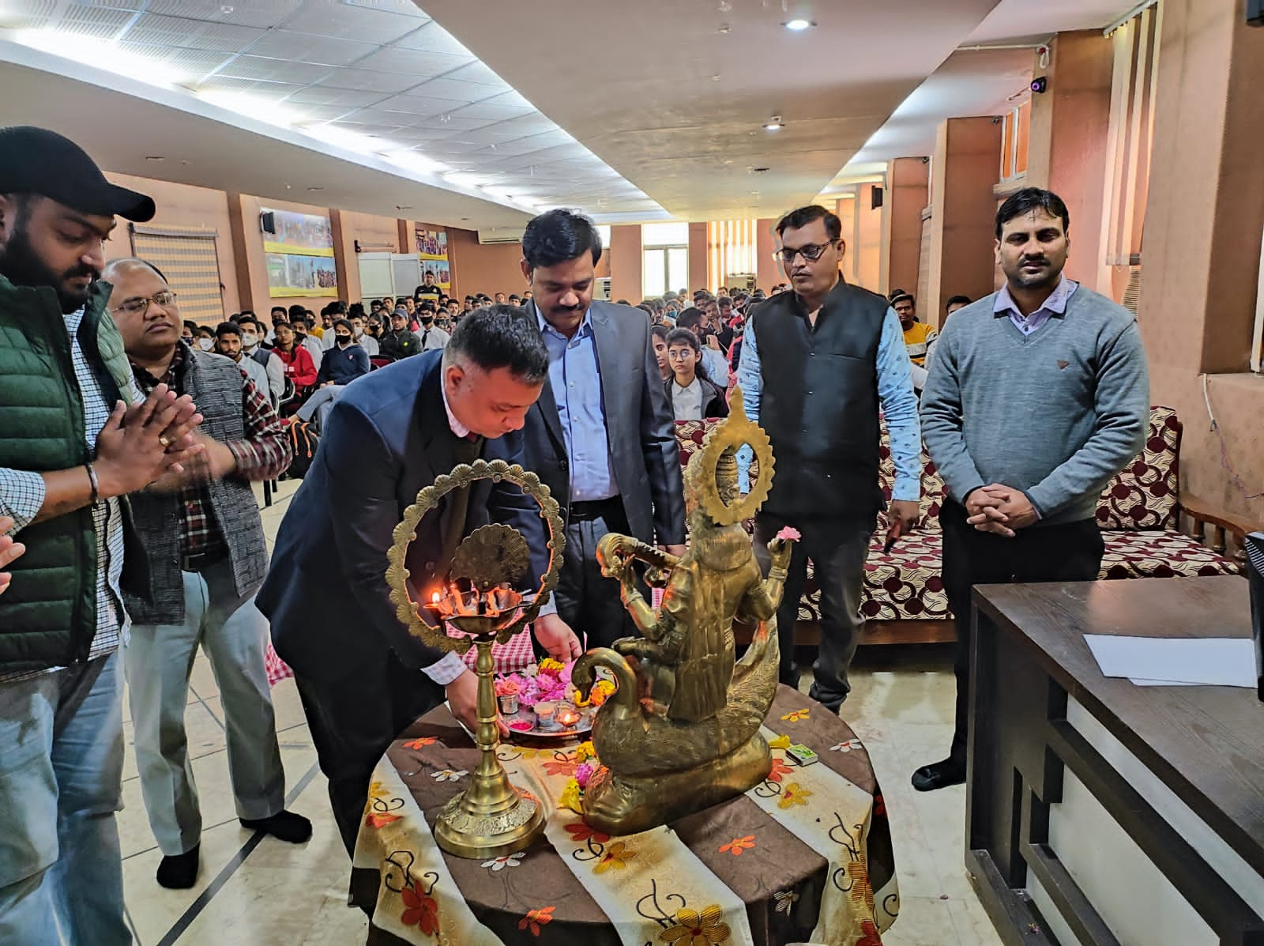

|  |  |  |  |  |  |  |  |
| --- | --- | --- | --- | --- | --- | --- | --- |
| **BCA 1st YEAR** | | **BCA 2nd YEAR** | | | **BCA 3rd YEAR** | | |
| **S.NO** | **Student Name** | **S.NO** | **Roll No.** | **Student Name** | **S.NO** | **Roll No.** | **Student Name** |
| **1** | ABHAY KUMAR TIWARI | **1** | 205901007002 | ABHISHEK YADAV | **1** | 175901007001 | ADITYA SHUKLA |
| **2** | ABHIJEET SINGH | **2** | 205901007003 | AKSHAY KUMAR | **2** | 195901007001 | ABHAY SEN |
| **3** | ABHISHEK PAL | **3** | 205901007004 | AMAN VISHWAKARMA | **3** | 195901007002 | ABHIJEET TIWARI |
| **4** | ADRIAN ALEX BRAGANZA | **4** | 205901007005 | ANKIT KUMAR | **4** | 195901007003 | ABHISHEK RAJPOOT |
| **5** | AKHILESH SINGH | **5** | 205901007006 | APOORVA DWIVEDI | **5** | 195901007004 | ABHISHEK SINGH |
| **6** | AKSHAY YADAV | **6** | 205901007007 | ASHUTOSH RAIKWAR | **6** | 195901007005 | ABHISHIKHA PATHWAR |
| **7** | DEV SINGH KUSHWAHA | **7** | 205901007008 | AYUSH KUMAR | **7** | 195901007006 | AMAN KUMAR |
| **8** | DIPAK KUMAR | **8** | 205901007009 | DRISHTI CHAUHAN | **8** | 195901007007 | ARSHAD KHAN |
| **9** | GULSHAN RAJPOOT | **9** | 205901007010 | HIMANSHU YADAV | **9** | 195901007008 | AVINASH MITTAL |
| **10** | HARSH GUPTA | **10** | 205901007011 | KUSHAGRA GUPTA | **10** | 195901007009 | BRAJENDRA BHATT |
| **11** | HARSHIT SINGH RAJPOOT | **11** | 205901007012 | LALIT YADAV | **11** | 195901007010 | DEEPESH LEKHWANI |
| **12** | KARTIK AHIRWAR | **12** | 205901007013 | MANISH | **12** | 195901007011 | DURGESH YADAV |
| **13** | KEERTI | **13** | 205901007016 | PAVAS JAIN | **13** | 195901007012 | GOPAL JI PAL |
| **14** | KULDEEP SHARMA | **14** | 205901007017 | PRIYANSHU SHRIVASTAVA | **14** | 195901007013 | IZHAR ASHRAF KHAN |
| **15** | KUNAL GUPTA | **15** | 205901007018 | RAGHVENDRA SINGH NIRANJAN | **15** | 195901007014 | MOHAMMAD SAMIR |
| **16** | MOHAMMAD AMAN | **16** | 205901007019 | RAJVEER SINGH | **16** | 195901007015 | MOHIT KUMAR |
| **17** | MOHAMMAD AYAZ | **17** | 205901007020 | RISHABH NAGAR | **17** | 195901007018 | PRIYANKA VERMA |
| **18** | MOHD AKRAM | **18** | 205901007021 | SAKSHAM SAHU | **18** | 195901007019 | RIZWAN BEG |
| **19** | MOHD ZAHEER | **19** | 205901007022 | SARTHIK JAIN | **19** | 195901007020 | SACHIN KUMAR |
| **20** | NILAY YADAV | **20** | 205901007023 | SAURABH | **20** | 195901007021 | SAHIL DUBEY |
| **21** | PANKAJ KUMAR | **21** | 205901007024 | SHOAB AHMED | **21** | 195901007022 | SHAILENDRA KUMAR |
| **22** | RAGHVENDRA NAYAK | **22** | 205901007025 | SUMIT SWAMI | **22** | 195901007023 | SHALINI VERMA |
| **23** | ROHAN PRATAP SINGH | **23** | 205901007026 | SUNAKSHI | **23** | 195901007024 | SHIVAM VERMA |
| **24** | SAHIL MISHRA | **24** | 205901007027 | TANISHA SAHU | **24** | 195901007025 | SHIVKANT |
| **25** | SAHIL VISHWKARMA | **25** | 205901007028 | VIKRAM SINGH |  |  |  |
| **26** | SAHIL YADAV | **26** | 205901007029 | VISHAL ALPURIA |  |  |  |
| **27** | SAKSHI SHRIVASTAVA | **27** | 205901007030 | VISHAL SINGH |  |  |  |
| **28** | SHAILENDRA RAI | **28** | 205901007031 | YASH VEER |  |  |  |
| **29** | SHIVAM CHANDPURIA | **29** | 205901007032 | ZUBAIR AHMAD |  |  |  |
| **30** | SHIVAM NAGARIYA | **30** | 195901007017 | PRANABH YAGGIK |  |  |  |
| **31** | SHUBHAM DWIVEDI |  |  |  |  |  |  |
| **32** | SOMYA TYAGI |  |  |  |  |  |  |
| **33** | SUMESH KUMAR LODHI |  |  |  |  |  |  |
| **34** | SUMIT KUMAR VERMA |  |  |  |  |  |  |
| **35** | SUYASH SONI |  |  |  |  |  |  |
| **36** | YASH GUPTA |  |  |  |  |  |  |